Urbanism and Disurbanism
Alla Vronskaya, Swiss Federal Institute of Technology (ETH), Zurich

‘Urbanism’ and ‘disurbanism’ were the two approaches that confronted each other during the so-called ‘discussion of socialist settlement’ that took place in the Soviet press and inside party and state institutions in 1929-1930. The key debate in the history of early-modernist Soviet town planning, the discussion betrayed the problematic character of social and architectural projectionism at the core of much modernist thinking. Its significance at the time far transcended the scope of utopian architecture: the discussed proposals were seen as viable models for implementation, influencing many urban planning schemes designed at the time, while participants included powerful Soviet functionaries, bureaucrats, and members of the scientific and cultural elite. The opposing parties - the ‘urbanists,’ represented by economist Leonid Sabsovich, and the ‘disurbanists,’ whose major speaker was economist Mikhail Okhitovich - debated the form of human settlement following the awaited disappearance of the difference between the town and the country in a socialist society.
Sabsovich’s book Goroda budushchego i organizatsia sotsialisticheskogo byta [The Cities of the Future and the Organization of Socialist Everyday Life] (1929) argued that the process of decentralization of urban agglomerations on the one hand, combined with the tendency towards the concentration of agricultural settlements on the other, led to the emergence of middle-size settlements. Larger than villages but much smaller than industrial cities, they were comprised of big buildings, where adult workers received hotel-style furnished rooms with centralized cooking and cleaning. Children were separated from their parents and collectively brought up in ‘children homes’ and ‘school cities.’ Sabsovich’s second book, Socialist Cities, followed in 1930. In it, he specified the size of the new settlements (50,000-60,000 people) and buildings (15-20 storeys high, housing 2000-3000 people each); a settlement, thus, comprised of 50-100 buildings, in a Corbusian tradition freely situated amidst abundant greenery. Sabsovich’s theory was supported by leading Constructivist architects brothers Viktor, Leonid, and Aleksandr Vesnin. Among the projects influenced by it were the Vesnins’ schemes for Stalingrad and Novokuznetsk (both 1930).
According to Okhitovich, who published his ideas in articles in Sovremennaia Arkhitektura [Contemporary Architecture; the journal of architectural Constructivism, edited by Moisei Ginzburg] a city was a ‘not a territorially organized human unity, but a social one.’ Relying on the expected development of motorized transportation, Okhitovich envisioned the shrinking of time and space with the increase of speed, which led to a process of centrifugal repulsion within settlements. Unlike traditional urban agglomerations, these new settlements avoided center/periphery segregation. Residents occupied small individual houses (husbands and wives were placed in adjacent yet separate units). The evenness of the distribution of human settlement led to an even distribution of culture, eliminating the center-periphery differentiation in this sphere. The process of disurbanization, for Okhitovich, was accompanied by ‘destationarization’: as production centers moved, so did residential housing, which became mobile or easily constructable (and dismantable). Okhitovich’s theory was employed by Ginzburg, who relied on it in his project of the Green City, a vacation town near Moscow (1930).
Focusing on the conceptions of urbanism and disurbanism and aiming to find a middle way of solving the dilemma, public discussions of socialist settlement took place in October and November 1929 at the Communist Academy and the сlub of the State Planning Committee; in January 1930 socialist settlement became the theme of the journal Revolutsia i kultura [Revolution and Culture], published by the Central Committee of the Communist Party. The discussion was officially closed in May 1930, when the Central Committee published a decree ‘On the work on reconstructing everyday life,’ which condemned both urbanism and disurbanism as utopian and unrealistic; its repercussions, however, continued to influence Soviet urban planning during the subsequent years, as others attempted to give their responses to the problem of socialist settlement.
Most importantly, the question was developed by Nikolai Miliutin, the head of the Government Commission on the Construction of Socialist Cities - a Soviet functionary, well acquainted with the materials of the discussion as well as with the positions of the State Planning Committee and the ministries of health and culture and education. Published at the end of 1930, his book Sotsgorod [Socialist City], subtitled ‘The Problem of the Construction of Socialist Cities: Key Questions of Rational Planning and Construction of Soviet Settlements,’ proposed a ‘conveyer-functional system’ of settlement, which was based on models of linear cities developed earlier by Ginzburg (Green City), Nikolai Ladovskii (paraboloid scheme for the growth of Moscow) and, before that, by Spanish urban planner Arturo Soria y Mata (linear city). Miliutin compared his settlement to a conveyor belt, which united eating, education, culture and other urban functions into a single uninterrupted process. Unlike the urbanists and the disurbanists, who attempted to predict the development of urban form under socialism, Miliutin limited his ambitions to a design of a settlement for the ‘transitory period’ in which he lived.
In the mid-1930s, following Soviet architecture’s turn to traditional models of urbanism, the legacy of the debate was rejected in the USSR. While architects were almost never subjected to repression, the three key protagonists of the socialist settlement discussion lost their professional positions, which made their biographies the subject of contemporary historical investigation. Sabsovich stopped his publishing activity and his subsequent fate remains unknown. Okitovich was subjected to repression in 1935 and executed in 1937. Miliutin fell into disgrace in 1937, but continued to work in the office of the construction of the Palace of the Soviets (as its director from 1940).
Selected Primary Sources:
Sabsovich, L. M. (1929) Goroda budushchego i organizat︠s︡ii︠a︡ sot︠s︡ialisticheskogo byta [The Cities of the Future and the Organization of Socialist Everyday Life]. Moskva: Gos. tekh. izd-vo.
Sabsovich, L. M. (1930) Sot︠s︡ialisticheskie goroda [Socialist Cities]. Moskva: Gosizdat RSFSR ‘Moskovskiĭ rabochiii’.

Okhitovich, M. (1929), ‘Zametki po teorii rasselenia’ [‘Notes on the theory of settlement’], Sovremennaia Arkhitektura [Contemporary Architecture], No.1-2 1930: 7-15.
Mili︠u︡tin, N. A. (1974) Sotsgorod; the problem of building socialist cities. Cambridge, MA: M.I.T. Press.

Further Reading:

Khazanova, V. E. (1980). Sovetskai︠a︡ arkhitektura pervoĭ pi︠a︡tiletki: problemy goroda budushchego [Soviet architecture of the First Five-Year Plan: the problems of the city of the future]. Moskva: Izd-vo ‘Nauka.’
Hudson, Hugh D. (1994) Blueprints and blood: the Stalinization of Soviet architecture, 1917-1937. Princeton, N.J.: Princeton University Press.
Khan-Magomedov, S. O. (2009) Mikhail Okhitovich. Moskva: Russkiii avangard.
Khmelʹnit︠s︡kiii, Dmitriii, and E. N. Mili︠u︡tina (2013) Nikolai Mili︠u︡tin v istorii Sovetskoi arkhitektury [Nikolai Miliutin in the history of Soviet architecture]. Moskva : Novoe literaturnoe obozrenie, 2013.

Illustrations:
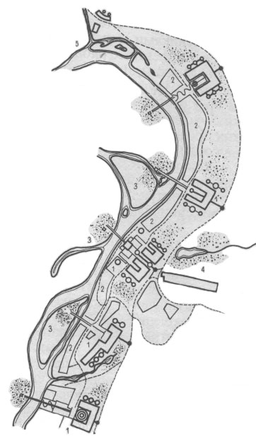
Aleksandr and Leonid Vesnin, Stalingrad, general plan (1930)
http://arx.novosibdom.ru/node/2384
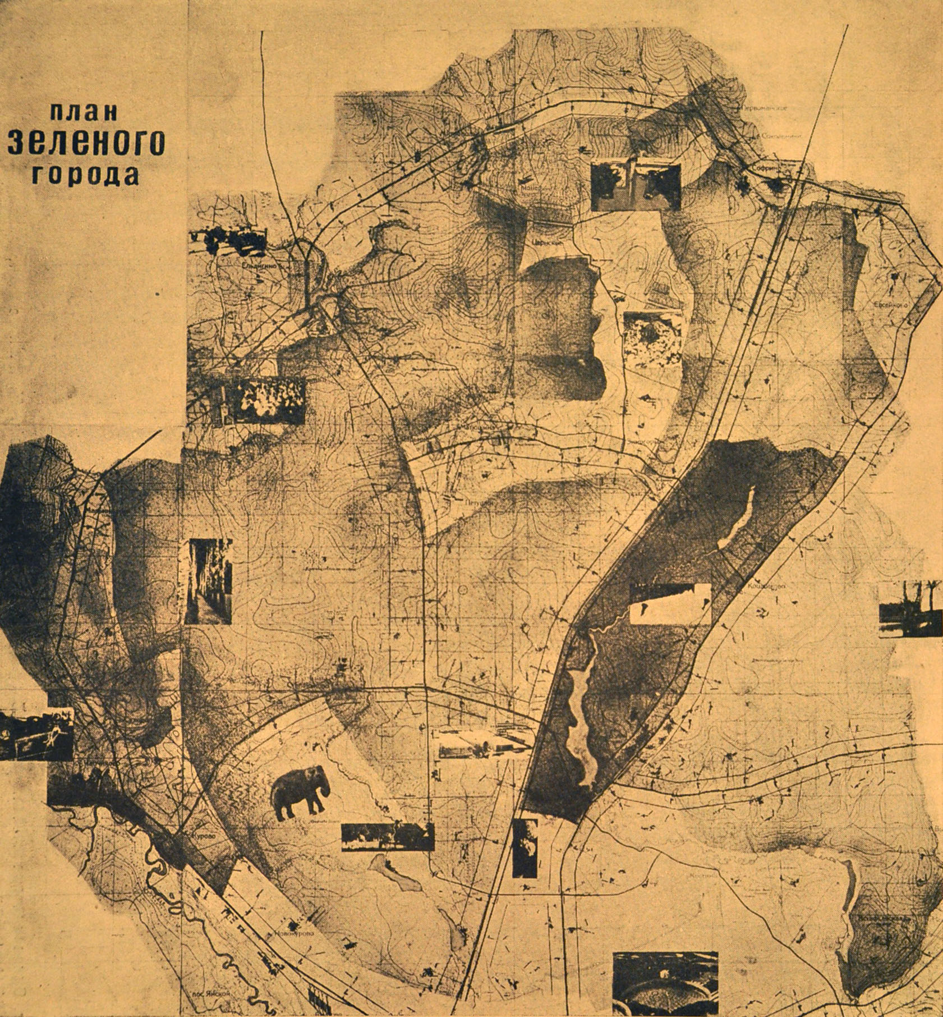
Moisei Ginzburg, Green City. Published in Stroitel’stvo Moskvy, No. 3, 1930: 14.
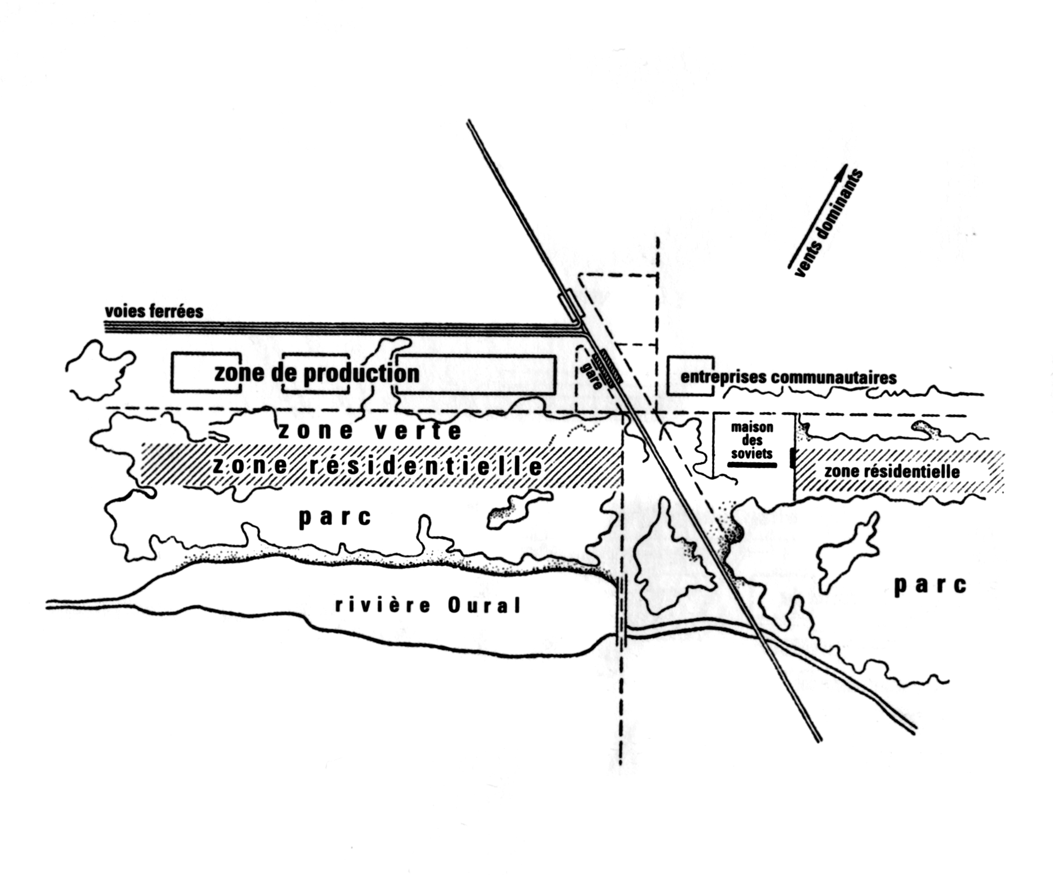
Scheme of the planning of Magnitogorsk, Russia according to the conveyer-functional system. Illustration from Nikolai Miliutin, Sotsgorod [Socialist City] (Moscow and Leningrad: Gosudarstvennoe Izdatel’stvo, 1930) 28.

